

Walchand College of Engineering, Sangli

(Government aided Autonomous Institute)

Department of Computer Science and Engineering
TY CSE Mini Project 1
Report on

RAKSHASETU

Submitted by

Saurabh Doiphode | 23510009
Srushti Garad | 23510081
Yash Jamdade | 23510109

Under the guidance of

Dr. A. R. Surve

Department of Computer Science and Engineering,
Walchand College of Engineering, Sangli

2025 - 2026

Walchand College of Engineering, Sangli
(Government aided Autonomous Institute)

Department of Computer Science and Engineering

CERTIFICATE

This is to certify that the Project Report entitled, “RAKSHASETU” submitted by Mr. Saurabh Doiphode, Mr. Yash Jamdade, Ms. Srushti Garad, to Walchand College of Engineering Sangli, India, is a record of bonafide project work of course Mini Project 1 7CS345 carried out by him/her under my/our supervision and guidance and is worthy of consideration for the award of the degree of Bachelor of Technology in Computer Science & Engineering of the Institute.

Dr. A. R. Surve | Dr. B. F. Momin |  | Dr. A. R. Surve
Guide | Mini project coordinator | External examiner | Head Of Department
Department of Computer Science and Engineering, | Department of Computer Science and Engineering, |  | Department of Computer Science and Engineering,
Walchand College of Engineering, Sangli | Walchand College of Engineering, Sangli |  | Walchand College of Engineering, Sangli

Acknowledgement

We would like to express our sincere gratitude to all those who guided and supported us throughout the successful completion of our Mini Project titled “RakshaSetu – Leopard Detection and Alert System.”

We are deeply thankful to Dr. A. R. Surve, our project guide, for his constant encouragement, valuable suggestions, and expert guidance at every stage of this project. His mentorship has been instrumental in shaping our understanding and helping us transform our ideas into a practical implementation.

We extend our heartfelt thanks to Dr. A. R. Surve, Head of the Department of Computer Science and Engineering, for providing us with the necessary facilities and an environment conducive to research and innovation.

We are also grateful to the Mini Project Coordinator and all the faculty members of the Department of Computer Science and Engineering, Walchand College of Engineering, Sangli, for their continuous motivation, support, and constructive feedback during the development of our project.

Declaration

I hereby declare that work presented in this project report titled “RAKSHASETU” submitted by me in the partial fulfillment of the requirement of the award of the degree of Bachelor of Technology (B. Tech) in the Department of Computer Science & Engineering, Walchand College of Engineering, Sangli is an authentic record of my project work carried out under the guidance of Dr. Anil Surve sir.

Date:03-11-25
Place: Sangli

Srushti Garad
(PRN: 23510081)

Table of Contents
Abstract 6
- Introduction and Related work 7
- Problem statement 8
- Objectives 9
- Methodology 10
- Project Diagrams (UML diagrams, Flow chart etc.) 11
- Test plan 15
- Results 16
- Conclusion 20
- Limitations of proposed solution
- Future scope/possible extension to proposed project
- References 21
- Scholarly contribution 22

List of Figures

  - figure 1 Functional Block Diagram

  - figure 2 UML Diagram

Acronyms

  - YOLO You Only Look Once (Object Detection Algorithm)

  - ESP32 Espressif Systems 32-bit Microcontroller

Abstract

In rural regions of India located near forest areas, leopard intrusions have become a serious and recurring issue, often resulting in the loss of livestock and, in some cases, human lives. Existing surveillance systems such as cameras and cages only provide monitoring but lack real-time alert mechanisms. To address this problem, the proposed project “RakshaSetu – Leopard Detection and Alert System” introduces a smart and automated solution that integrates Artificial Intelligence (AI), Internet of Things (IoT), and mobile technologies to ensure early detection and rapid response.
The system uses AI-based object and sound detection to identify leopards through CCTV cameras and microphones. Once detection occurs, it automatically triggers a local siren and sends instant alerts via a mobile application to forest officers, village heads, and residents. The app also provides safe route navigation, avoiding areas with recent leopard sightings, thus enhancing user safety.
The implementation involves technologies such as YOLOv8, OpenCV, Node.js, MongoDB, and Firebase, ensuring real-time communication and high accuracy. By bridging the gap between rural communities and authorities, RakshaSetu aims to reduce human-wildlife conflict, improve response time, and promote coexistence through non-lethal preventive measures.

1.Introduction and Related work

Background: Rural areas adjoining forests often face wildlife intrusion, especially by leopards. These incidents cause fear, property loss, and fatalities.

Existing Solutions:
- Surveillance cameras are widely used but lack intelligence to automatically identify and alert about animal presence.
- Manual monitoring is slow, inefficient, and dependent on human presence.
- Some forest departments use radio-collared animals for tracking, but this is not feasible for large populations.

Proposed Innovation:
- RakshaSetu integrates Artificial Intelligence, IoT, and cloud-based communication to create an automated detection and alert system.
- It uses real-time object detection and sound analysis to trigger alarms and notify users.

Technologies Used:
- Deep Learning (YOLOv8), OpenCV, IoT microcontrollers (ESP32/Arduino), React Native mobile app, Node.js backend, and MongoDB database.

Impact:
- Improves response time, minimizes damage, and enhances communication between villagers and authorities.
- Aligns with national initiatives like Digital India and Smart Village Mission to promote technology for social good.

2. Problem statement

Frequent leopard intrusions in rural and semi-urban areas result in loss of livestock and danger to human lives.

Although surveillance cameras exist, there is no automated or real-time alert system.

Residents, forest officers, and healthcare teams remain unaware until it’s too late.

Manual intervention delays emergency responses.

Hence, there is a need for a smart, AI-driven, automated system that can:
- Detect leopard presence using cameras and microphones.
- Instantly trigger alarms and notifications.
- Inform local authorities and villagers through a digital platform.
- Guide people through the safest available route.

3. Objectives
- To design and develop a real-time leopard detection system using computer vision and deep learning (YOLOv8).
- To integrate IoT-based siren and buzzer systems for immediate local alerts.
- To build a React Native mobile application for sending push notifications and providing safe route navigation.
- To ensure low latency and high accuracy of detection with minimal false positives.
- To make the system scalable, cost-effective, and reliable for rural environments.
- To use data storage for analysis of leopard movement patterns for forest departments.
- To support quick decision-making and emergency responses through automation.

4. Methodology

System Components:

- Camera & Microphone:
  - Captures real-time footage and audio in leopard-prone zones.
  - Works with minimal setup using Raspberry Pi or IP camera.

- Detection Module:
  - Implemented in Python 3 with OpenCV and YOLOv8 for real-time animal recognition.
  - YOLOv8-Tiny variant ensures high speed and efficiency on low-power devices.

- IoT Module:
  - Built on Arduino/ESP32 to control sirens and lights via GPIO pins.
  - Activates alarms instantly when detection occurs.

- Backend Server (Node.js + Express):
  - Handles communication between edge devices and mobile app.
  - Provides REST APIs for event logs, alert data, and device information.

- Database (MongoDB Atlas):
  - Stores all event logs including image URLs, timestamps, and GPS coordinates.

- Notification System (Firebase Cloud Messaging):
  - Sends real-time push alerts to users.

- Mobile Application (React Native):
  - Displays alerts, safe zones, live tracking, and historical data.
  - Allows villagers to report additional sightings manually.

- Data Flow:
- Camera captures image/video.
- Detection module analyzes input using YOLOv8.
- If leopard detected → Alert message sent to backend.
- Backend triggers IoT siren and sends FCM notifications.
- App displays alert and safest route to user.

5. Project diagrams

Functional Block Diagram:

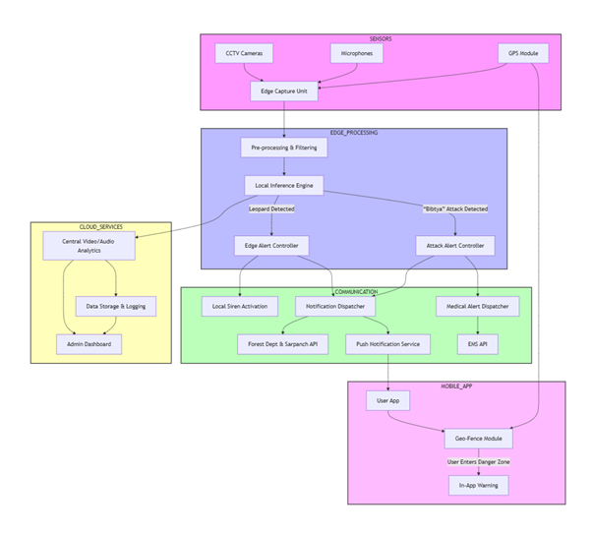

UML Diagram:

Use Case Diagram:

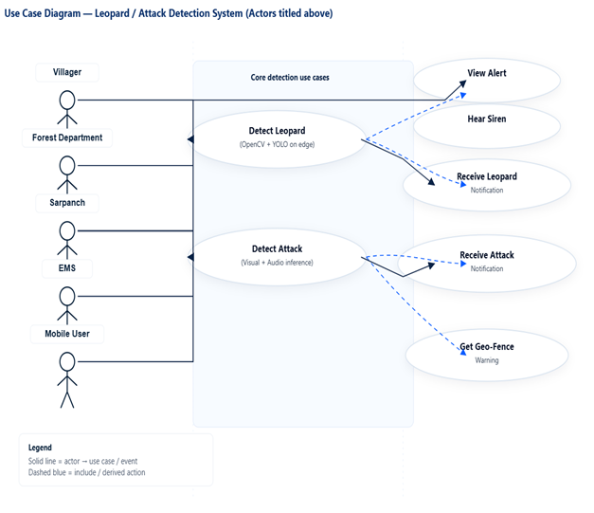
Activity Diagram:

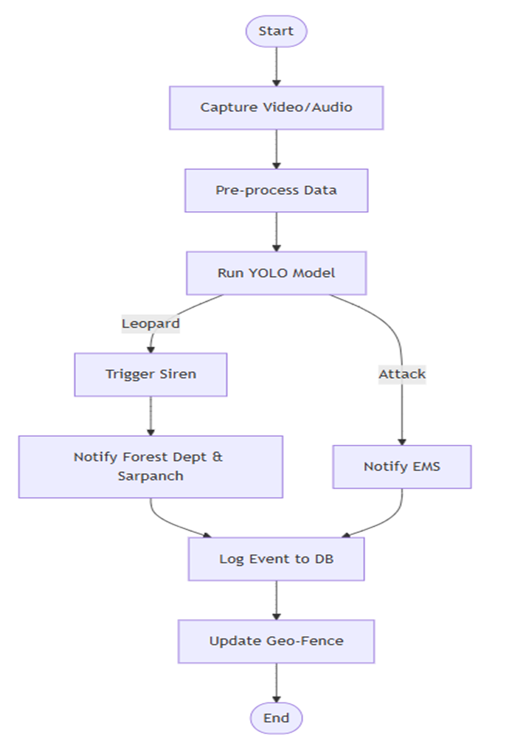

Class Diagram:

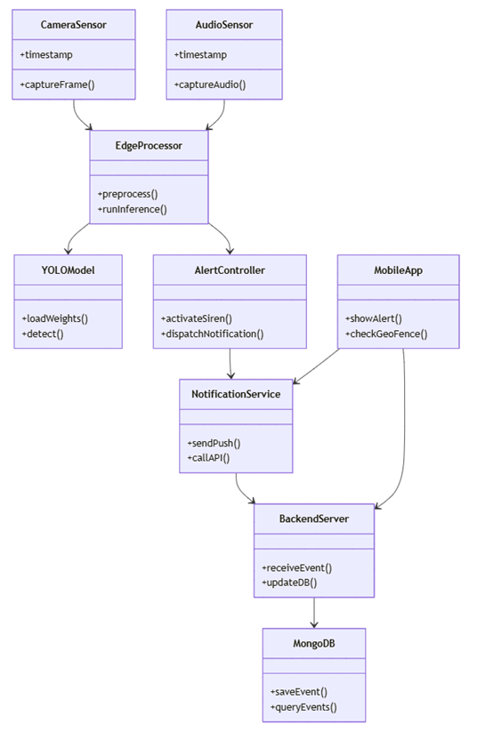

6. Test plan
• Type of Testing: Combination of Automated and Manual.
• Tools Used: OpenCV, Firebase Console, Postman, Expo Simulator.

Sr. No. | Input/Scenario | Expected Output | Testing Type
1 | Image of leopard in frame | System triggers siren and sends alert | Automated
2 | Image of dog/cat | No alert triggered | Automated
3 | Network failure | Local siren triggered, no cloud alert | Manual
4 | Push notification test | User receives alert on app | Manual
5 | Safe route request |  | Manual
  Route avoiding danger zone displayed

7. Results:
- System detected leopards accurately in recorded and live test videos.
- Siren and notification triggered within 3 seconds of detection.
- Safe route algorithm successfully avoided high-risk areas.
- Database stored alert events with image proofs.

Output:

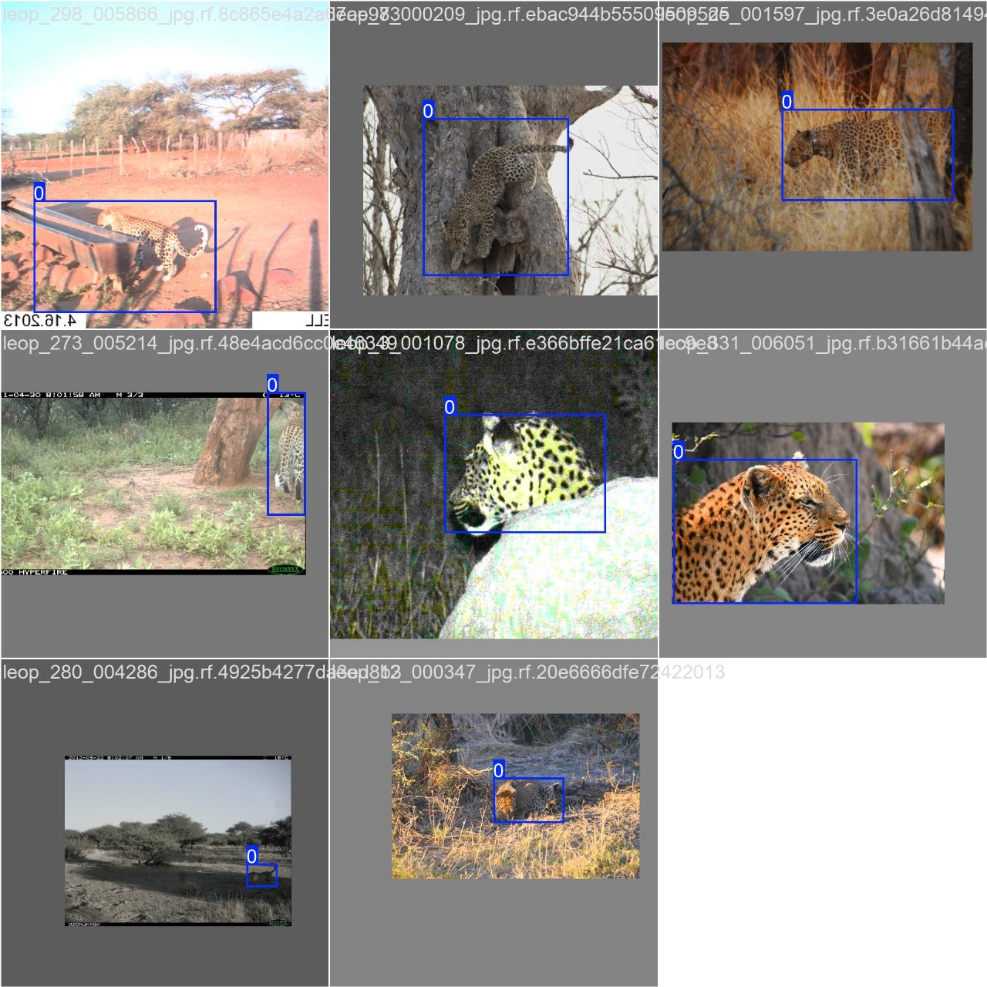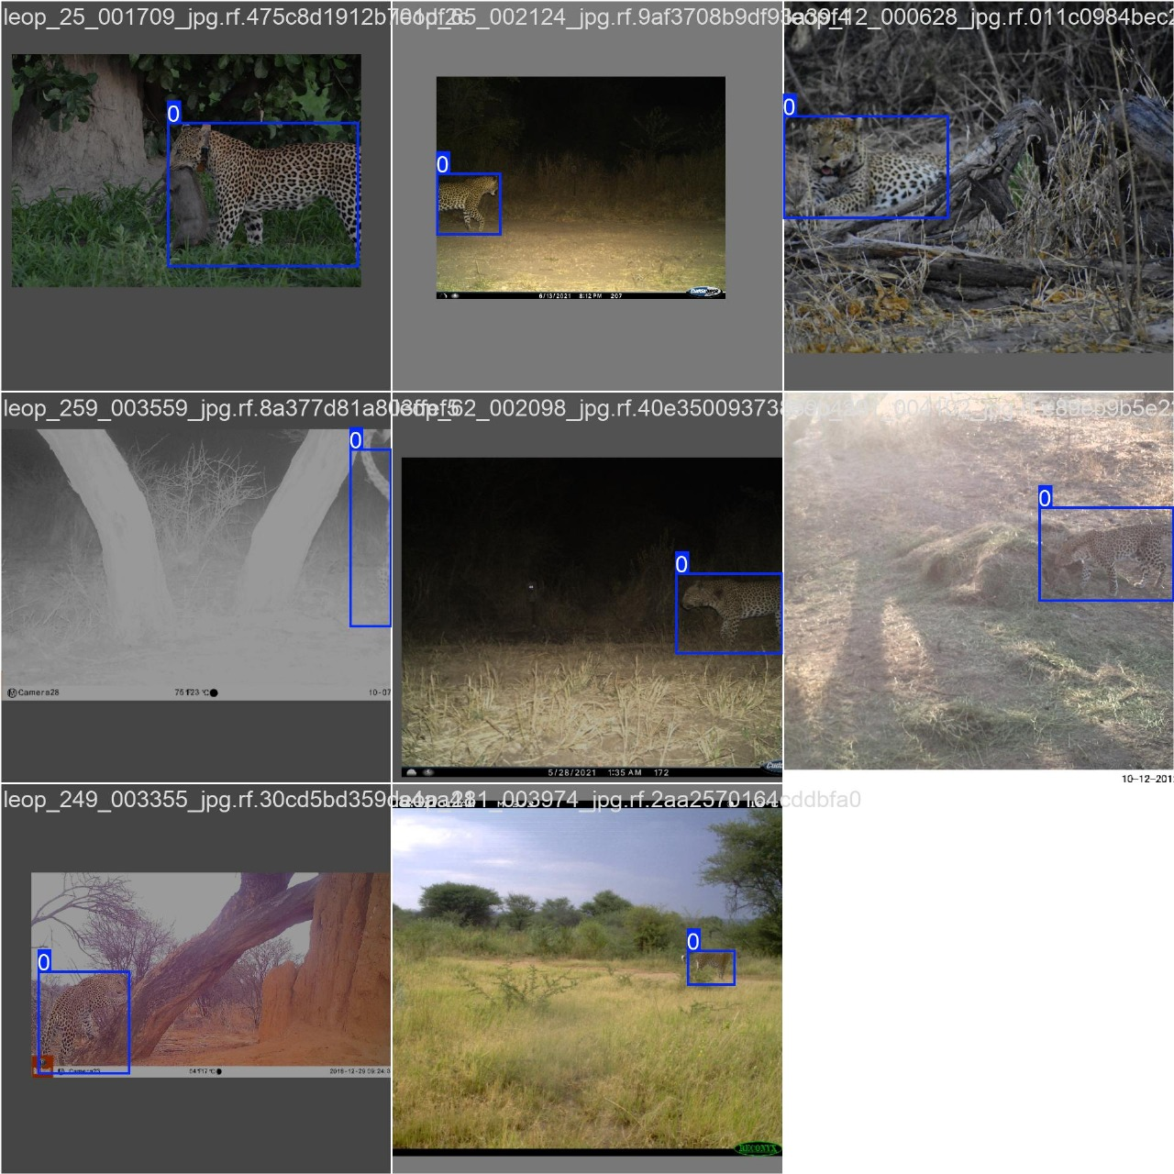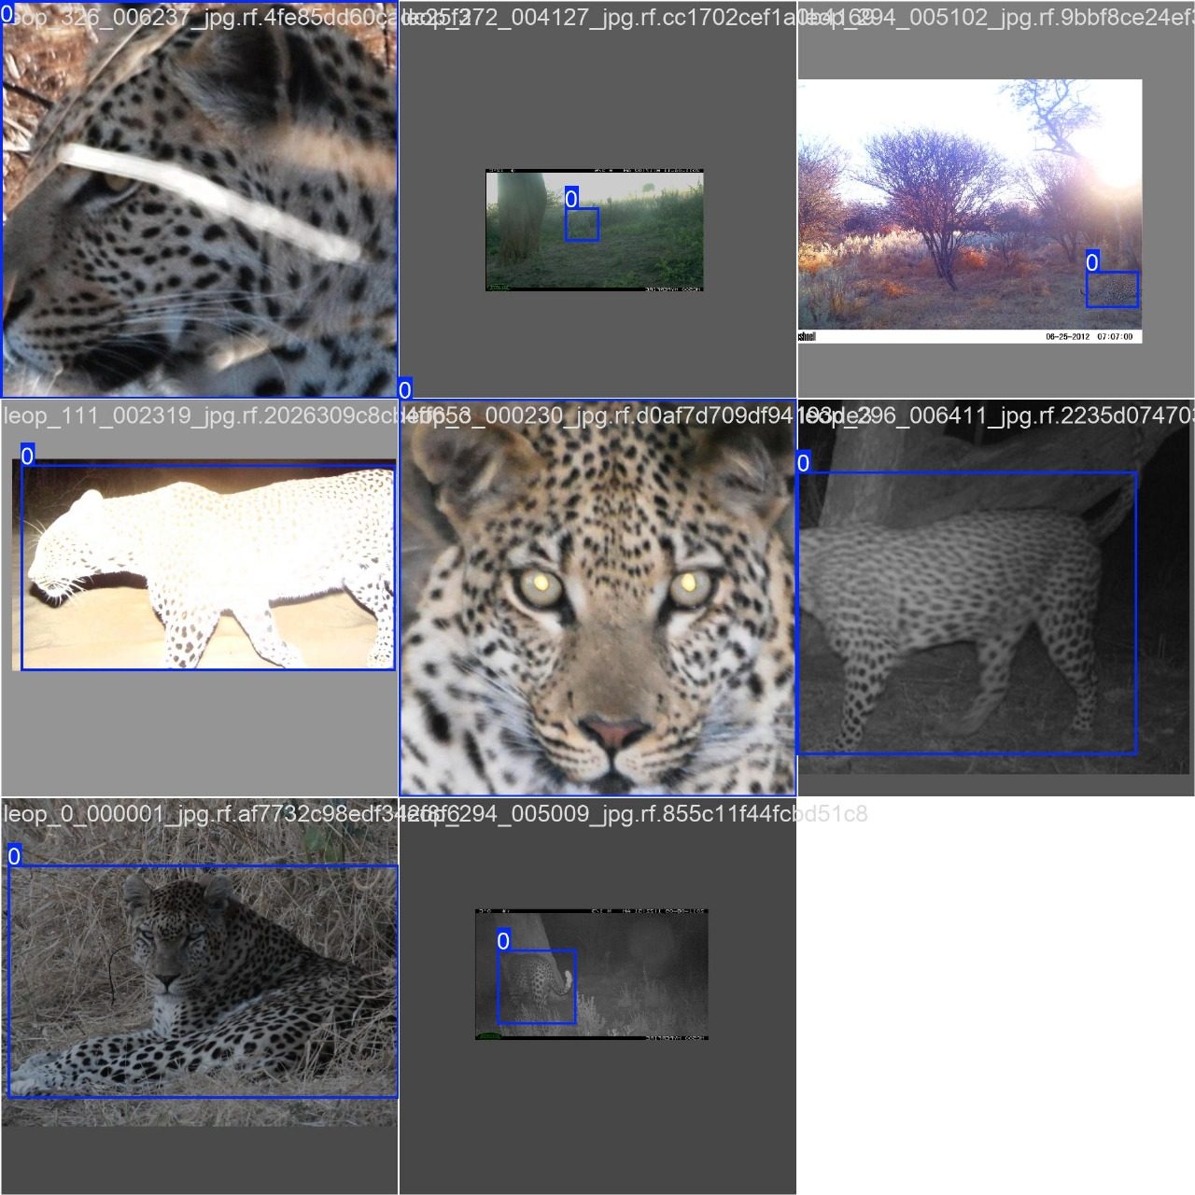

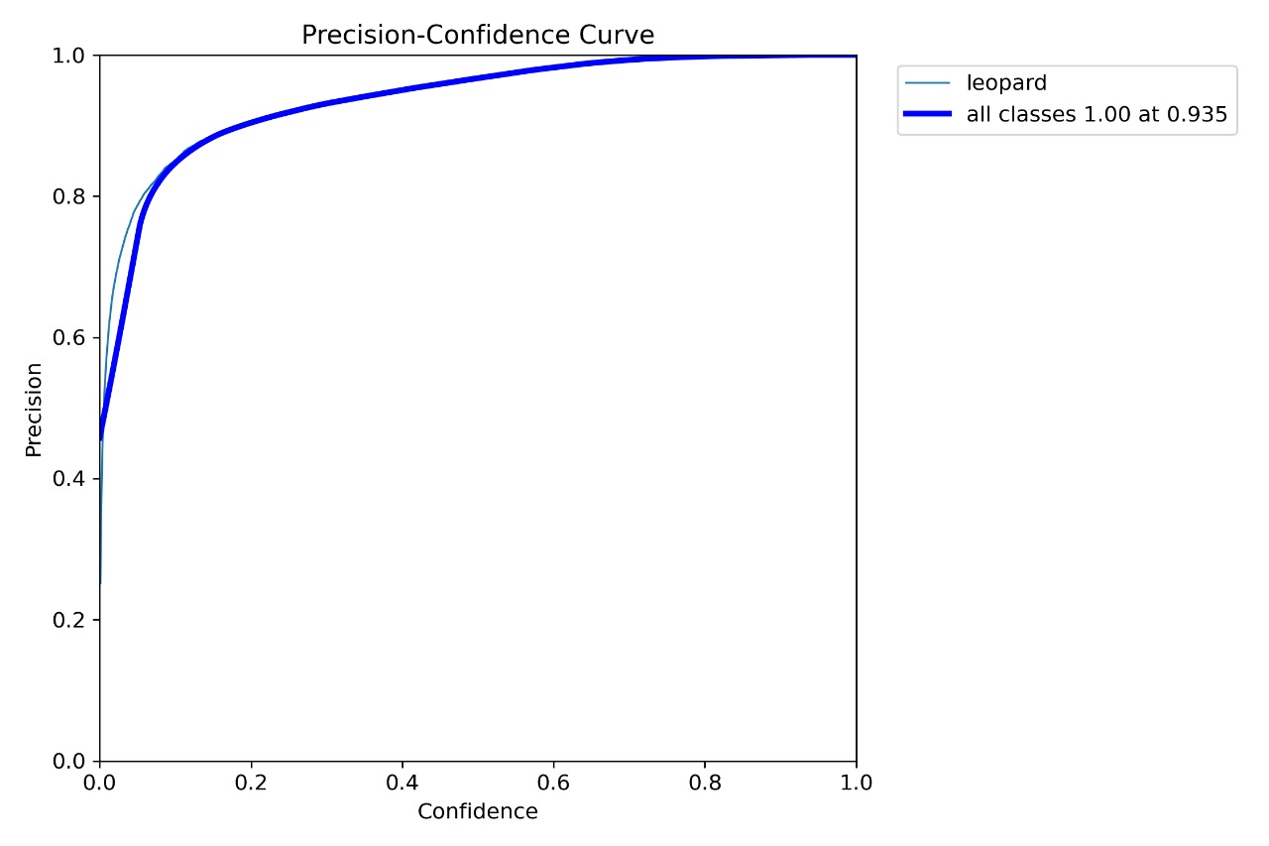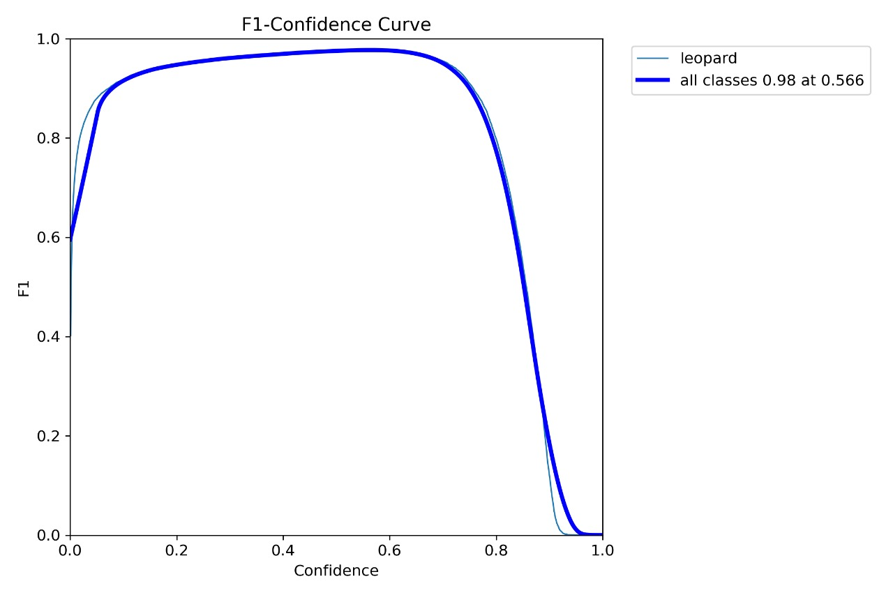

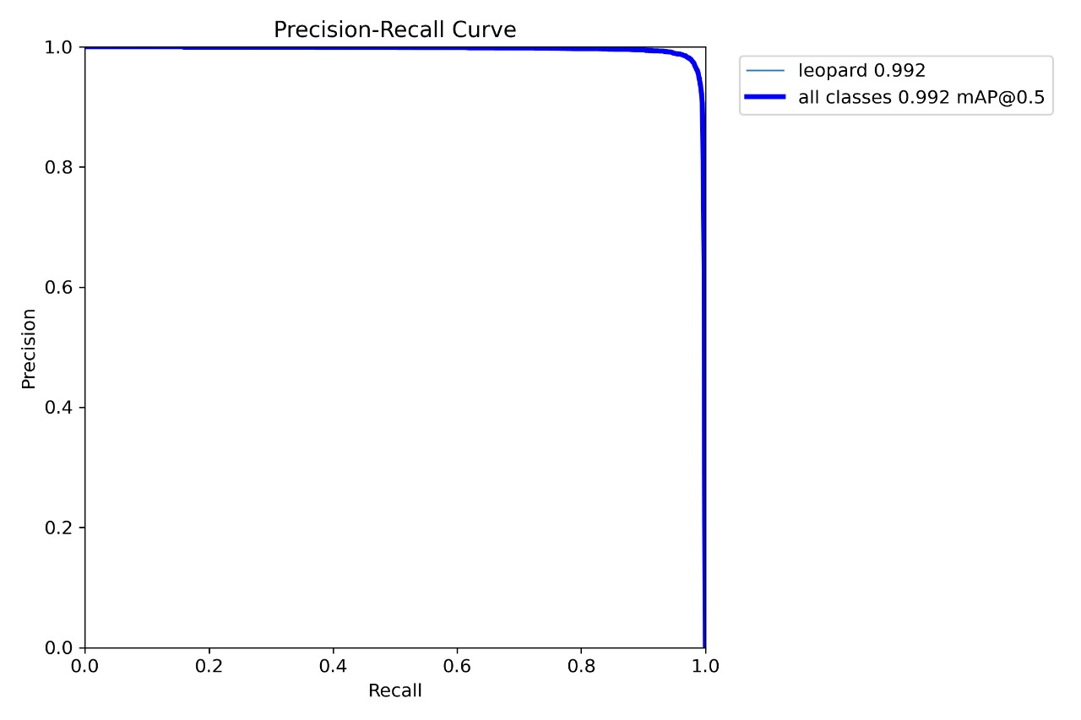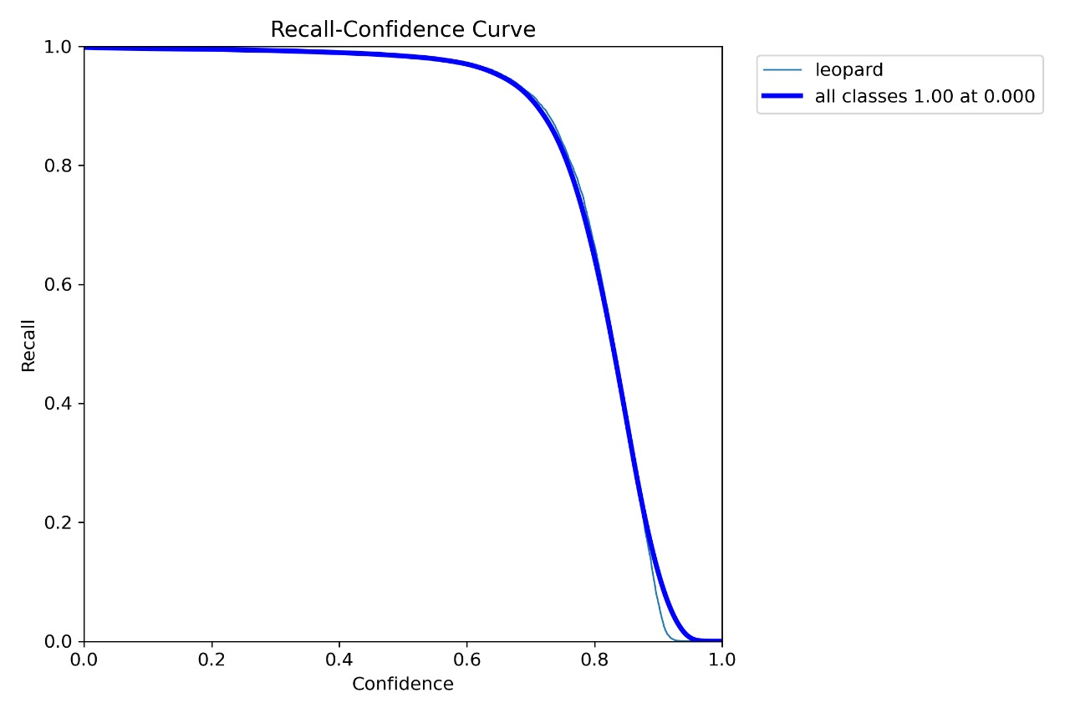

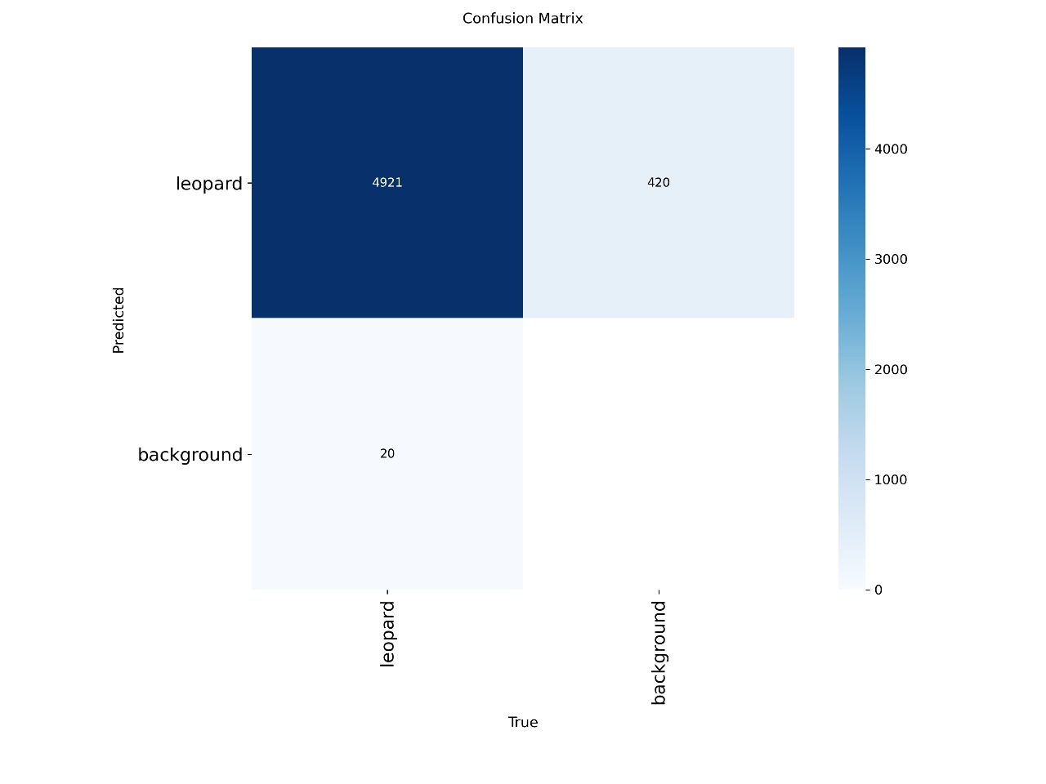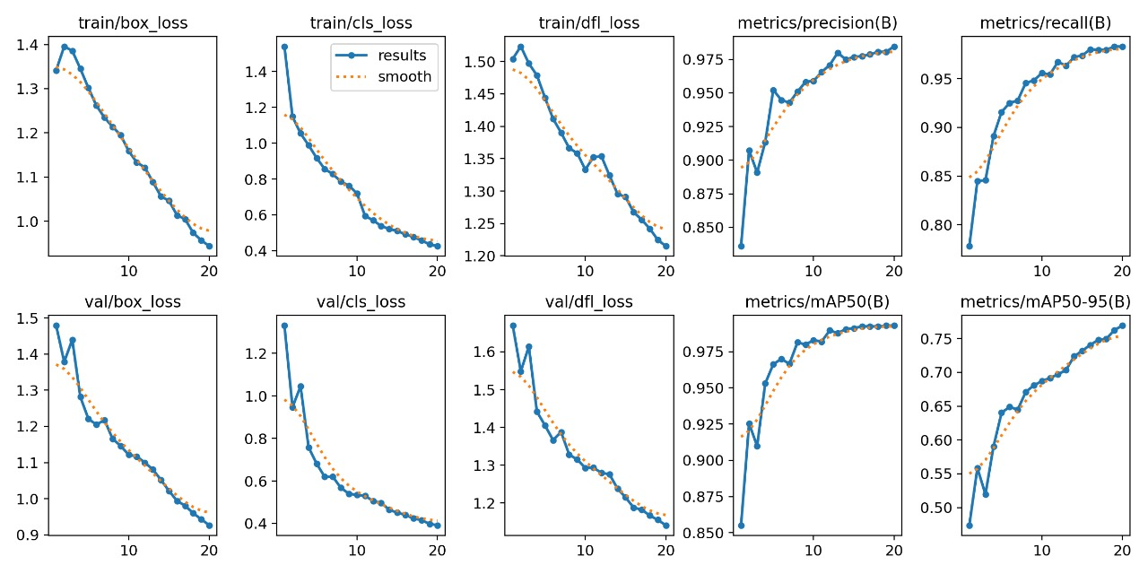

App:

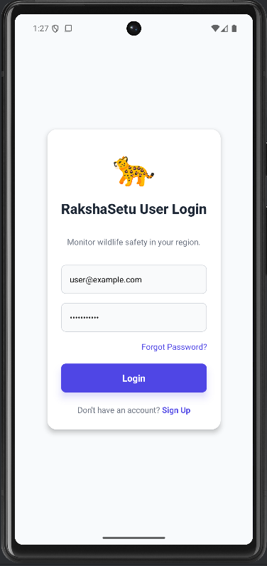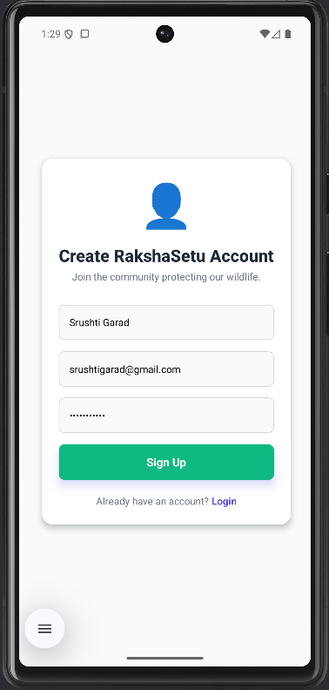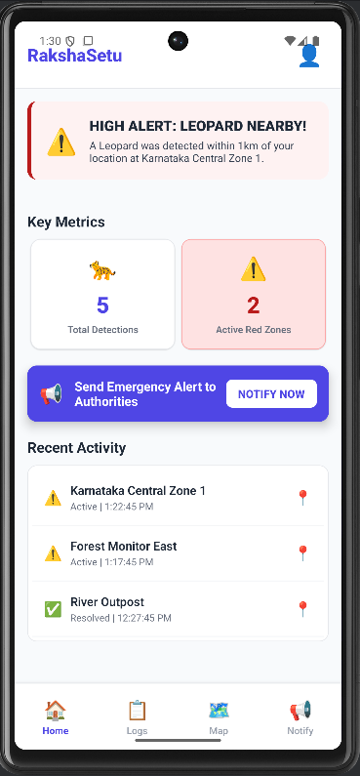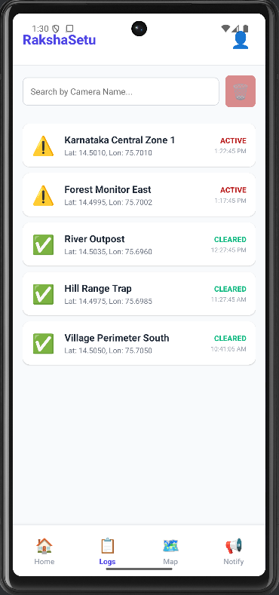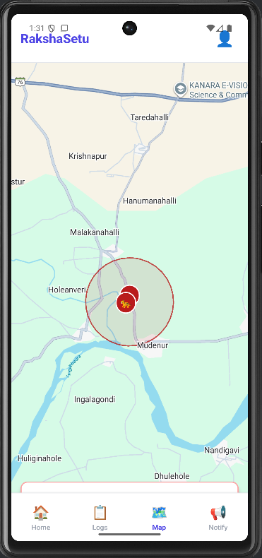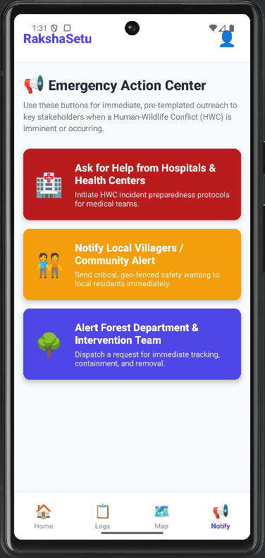

SQL Connectivity:

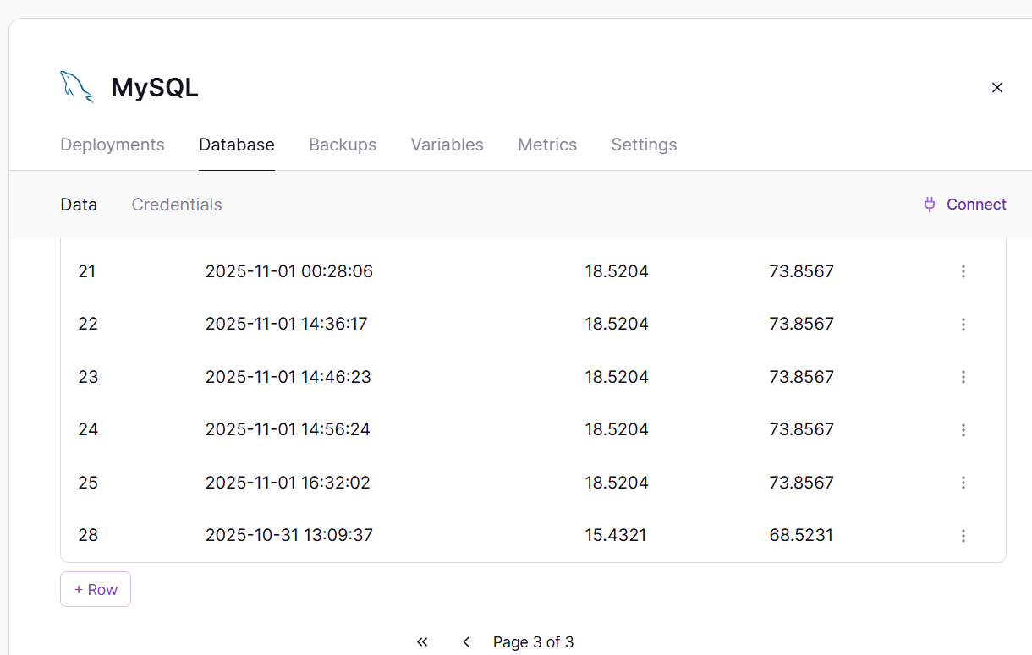

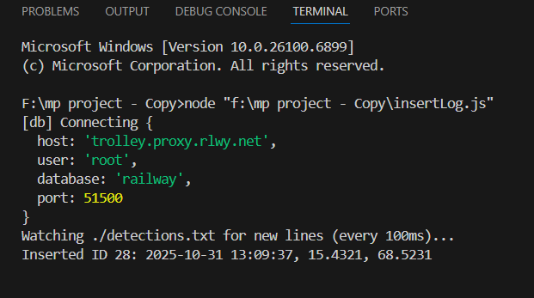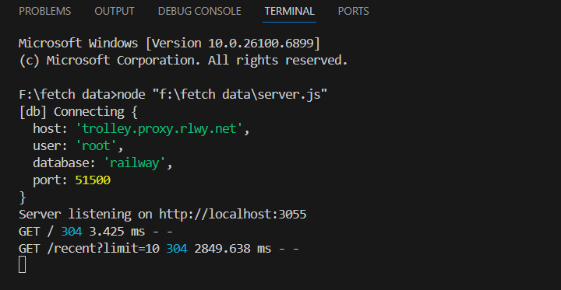

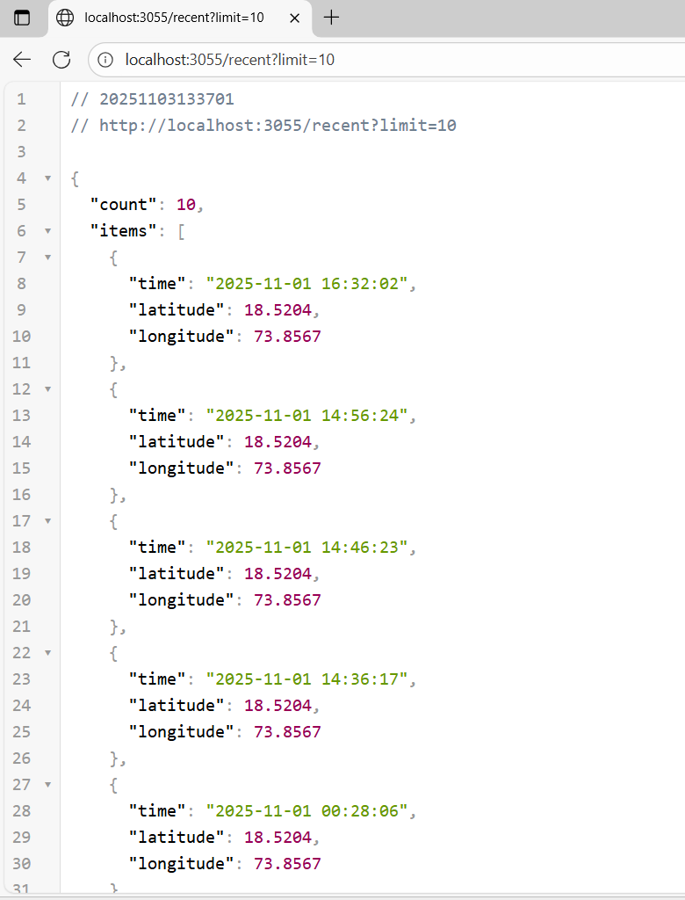

10. Conclusion
- RakshaSetu provides a proactive solution to the problem of human–leopard conflict.
- The integration of AI, IoT, and mobile technology enables faster detection and alert dissemination.
- The system improves rural safety, ensures better communication, and minimizes losses.
- The prototype demonstrates strong performance and can be scaled to cover larger forest regions.
- It promotes coexistence by alerting rather than harming wildlife.

Limitations
- Detection accuracy may reduce in poor lighting, fog, or dense vegetation.
- Dependence on continuous power supply and stable internet connection.
- Initial hardware installation costs may be high for large-scale coverage.
- Audio detection might misclassify background animal sounds.

Future Scope
- Extend model to detect other wild animals (tigers, elephants, bears).
- Use drones for aerial monitoring and real-time tracking.
- Implement solar-powered edge devices for remote deployment.
- Develop a central web dashboard for forest departments.
- Deploy system across multiple high-risk regions under Smart Village Initiative.
- Collaborate with wildlife NGOs for awareness and data collection.

11. References
- Redmon, J., & Farhadi, A. (2018). YOLOv3: An Incremental Improvement. arXiv:1804.02767.
- Ultralytics (2025). YOLOv8 Documentation. https://docs.ultralytics.com
- OpenCV (2025). OpenCV Documentation. https://docs.opencv.org
- React Native (2025). React Native Documentation. https://reactnative.dev/docs
- Node.js (2025). Node.js Documentation. https://nodejs.org/en/docs
- MongoDB (2025). MongoDB Documentation. https://www.mongodb.com/docs
- Frontline (2024). Deadly Leopard Attacks Are on the Rise – The Hindu Frontline.
- Arduino (2025). Arduino Documentation. https://docs.arduino.cc

12.Scholarly contribution

- The project “RakshaSetu – Leopard Detection and Alert System” is currently in its development and prototype testing phase.
- The system demonstrates the integration of AI-based object detection, IoT alert mechanisms, and mobile application connectivity, representing an innovative approach to wildlife monitoring.
- The project has contributed to the learning and practical implementation of technologies such as YOLOv8, OpenCV, Node.js, MongoDB, and Firebase.
- The team has documented the research and design approach thoroughly, which can serve as a reference for future research or full-scale deployment.
- The project was presented as part of the Mini Project evaluation under the Department of Computer Science and Engineering, Walchand College of Engineering, Sangli.
- A poster and project presentation were created to demonstrate system architecture, methodology, and prototype results to faculty members.
- Plans are in place to enhance the system and later submit it for publication or technical presentation at departmental or inter-college events.
- The project also aims for future submission to conferences related to AI in Wildlife Conservation or Smart Village Initiatives.

